
www.dezyneecole.com

Title of Project
One Frustration, Fixed
Project Report
Submitted By
Pooja Khandelwal &
Meenakshi Mali
Department – BCA
Semester – 3rd
Session – 2025–26

Project Report of
Identity 2026

Submitted to
Dezyne École College
Towards the Partial Fulfilment of
BCA 2nd Year

By
Meenakshi Mali & Pooja Khandelwal


www.dezyneecole.com
2025-2026

Acknowledgement

We take this opportunity to express our sincere gratitude to Dezyne École College for providing us with the knowledge, resources, and guidance essential to the successful completion of this project.
Our deepest thanks to our respected Principal, Dr. Vinita Mathur, for her visionary leadership and continuous encouragement. Her commitment to academic excellence and student growth has been a constant source of motivation and pride.
We are equally thankful to all our faculty members for their consistent support, expert advice, and valuable insights that shaped our learning and helped us achieve this milestone.
Lastly, we extend heartfelt thanks to everyone who directly or indirectly contributed to the success of this project.
We are proud to be part of Dezyne École College, an institution that truly nurtures professionalism, innovation, and purpose.

With sincere appreciation,
Meenakshi Mali & Pooja Khandelwal
Department of BCA
Dezyne École College, Ajmer

System Architecture

StockWise follows a browser-to-database request flow.

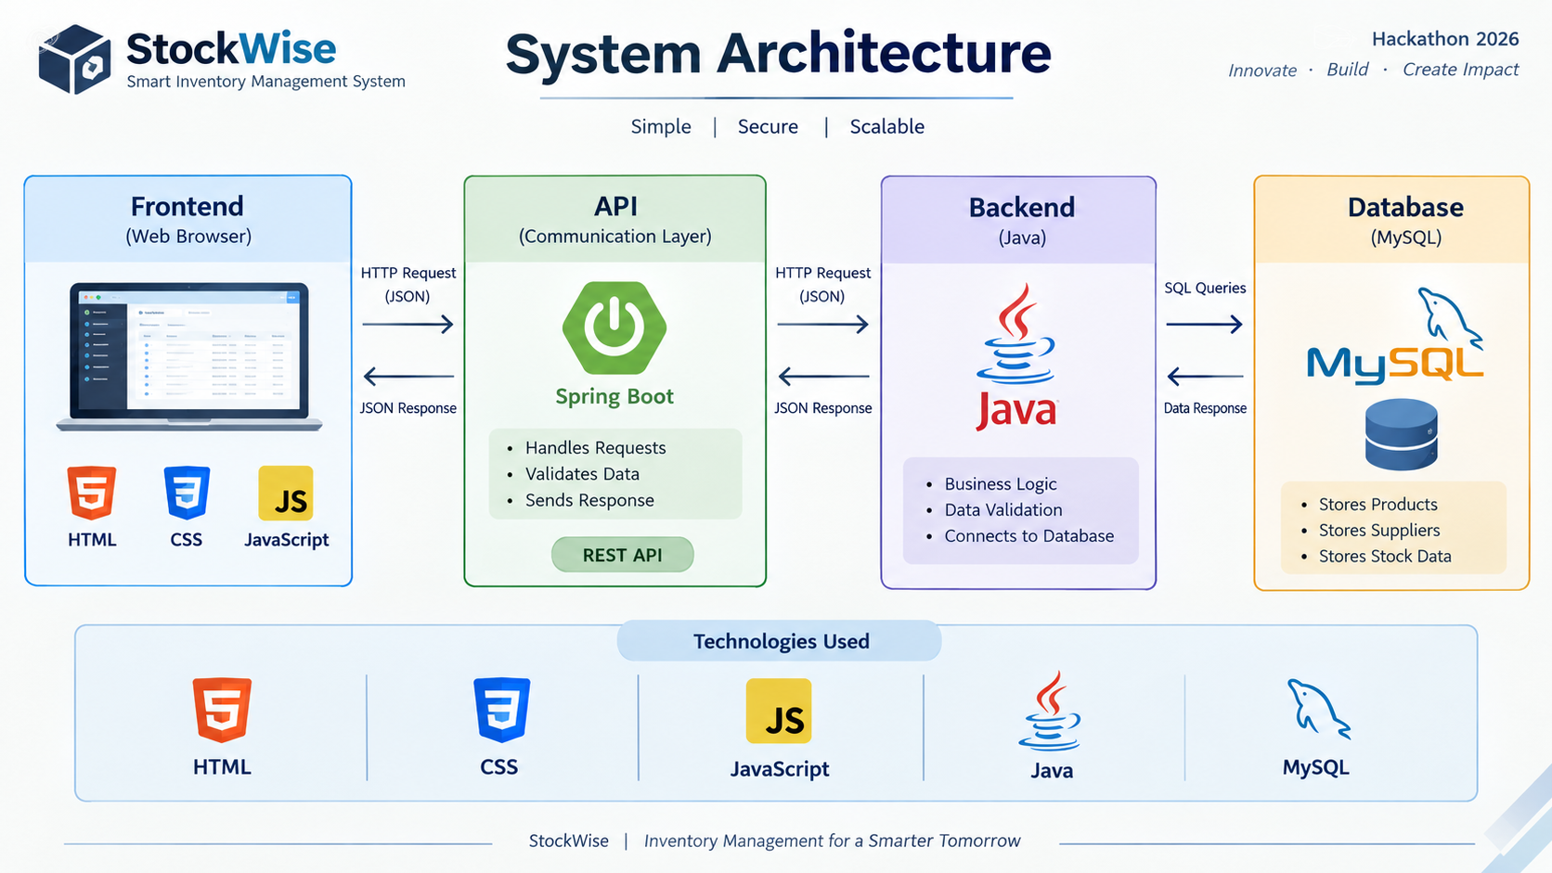

1 .Browser
The browser displays the application's interface and allows users to interact with product forms, tables, buttons, and other available screens.
2. JavaScript
JavaScript handles user interactions, performs frontend validation where implemented, sends requests to backend endpoints, and updates the interface based on the responses.
3. REST API
REST endpoints provide the communication interface between the frontend and backend. HTTP methods such as GET, POST, PUT, and DELETE can be used for retrieving, creating, updating, and deleting records.
4. Java and Spring Boot
The backend receives requests, validates input, executes application logic, and coordinates database operations through the configured repository or data-access layer.
5. MySQL Database
MySQL stores application records persistently. When a request requires a database operation, the backend communicates with MySQL and returns an appropriate response.
6. Response Flow
After processing a request, the backend returns an HTTP response. Depending on the endpoint, the response may contain JSON data, a success status, or an error message. JavaScript can use the response to refresh the relevant information displayed in the browser.

